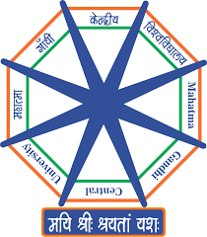
महात्मा गाँधी केन्द्रीय विश्वविद्यालय

Mahatma Gandhi Central University, Bihar
A Central University established by an Act of Parliament

Atal Bihari Vajpayee Central Library
(Please fill all details in capital letters)
(Faculty/Staff Membership Form)

Name ……………………………………………………………….. नाम- ...................................
Father’s name……………………………………………………… Date of Birth……………………………………………
Designation ……………………………………………………. पदनाम .........................................................


Department ……………………………………………………विभाग .......................................................
School ………………………………………………………… I’d No. ………………………………………………………….

Email ID ………………………………………………………………………….. Gender ………………………………………

Contact No. …………………………………………………………………………….. Blood Group………………………
Address ……………………………………………………………………………………………………………………………….

……………………………………………………………………………………………………………………………………………..

Signature of Faculty/Staff HOD / Dean (Signature with Stamp)

For Library Use Only

Membership Page No………………… Assistant Librarian (I/C) Card Entry [ ]
Card Print [ ]

Librarian (I/C)

